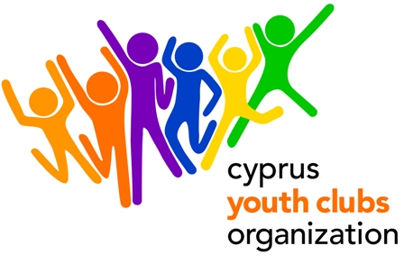
Youth in Action, Action 2 - European Voluntary Service
Young Improvers

PROJECT OUTLINE
- Project title: Young Improvers
- Organization: Cyprus Youth Clubs Organization (CYCO)
- Main theme for the project: Awareness raising regarding European values, projects and opportunities among the youth in both urban and rural areas of Cyprus.
- Project type: Youth in Action, Action 2 - European Voluntary Service
- Number of volunteers: 2
- Organizations’ Country: Cyprus
- The project starts: December 2010
- The project ends: June 2011
- Deadline for applications: 23 July 2010
- Duration: 6 months
- Group age (average): 18- 30
- Contact person: Dalosi Anna
- E-mail: adalosi@cyco.org.cy
- Tel.: +35722323260
- Fax: +35722321979
- Summary of the project:
“Young Improvers” is going to be an educational project clearly aiming at disseminating certain skills and awareness about European citizenship and youth participation among the members of the Youth Clubs. This project is expected to play an important role in the dissemination of the European values among the youth of Cyprus. The volunteers will support local volunteers who are familiar with the specific local needs, such as youth leaders and young volunteers. Volunteers will gather European documentation and will produce informational material. They will also support the European Projects & International Relations Coordinator in certain tasks as database update, communication, event and training organizing, helping youth clubs in partners search, facilitating events, promoting the Youth in Action Programme, promoting the EU values, key priorities, opportunities, etc. Given that young people can easily understand complicated messages if the messenger is a young person, the project will be based on the participatory approach of peer-to-peer education. The volunteers will receive mentoring from the European Projects & International Relations Coordinator of the CYCO. In the end of their service they will receive a certificate and recommendation letter (s).
- Financial aspects: participants will be reimbursed for the 90% of the travel cost. Accommodation, food and insurance will be covered by CYCO.
- How to participate:
FOR THE ORGANISATION: After you fill in the Part 3 of the 2010 application, send the scanned version to Anna Dalosi adalosi@cyco.org.cy and mail the original to
ANNA DALOSI, CYPRUS YOUTH CLUBS ORGANIZATION
P.O.Box 12106 CY 2341 NICOSIA , CYPRUS
FOR THE VOLUNTEERS: Fill in the Standard Application Form attached and send us a C.V (if available) to Anna Dalosi adalosi@cyco.org.cy

